**Notation**

We specify two reference frames: the **crystal reference frame** and the **global film reference frame**. Global film reference frame: $x_{1}^{F},x_{2}^{F},x_{3}^{F}.$ Crystal reference frame: $x_{1}^{C},x_{2}^{C},x_{3}^{C}$

For example, for a substrate with an $\left(110\right)$ orientation:

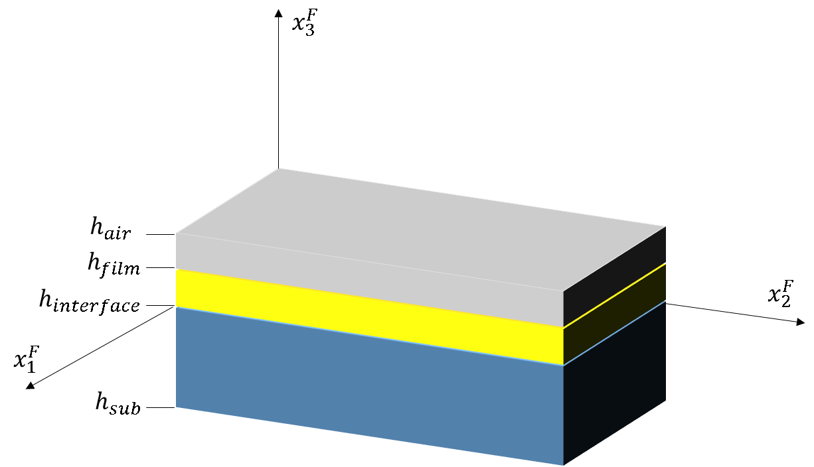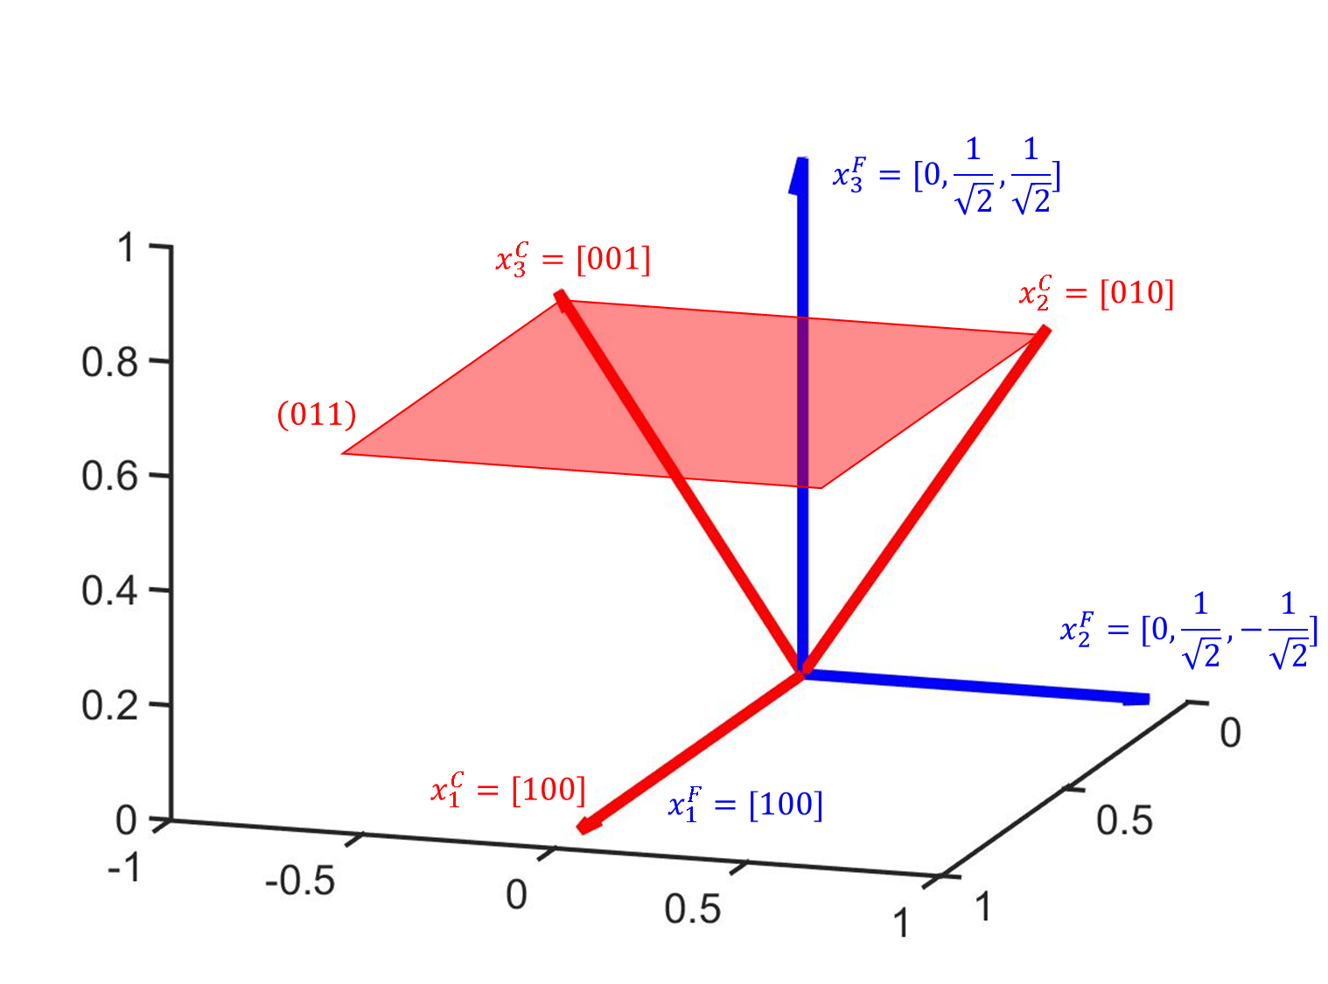

We can express a tensor using either the global film reference frame or the crystal reference frame. We will denote the tensor $V^{F}$ when it is expressed using the global film reference frame (the global film reference frame basis). We will denote the vector $V^{C}$ when it is expressed using the crystal reference frame.

We can switch a vector (a first rank tensor) between the two reference frames using rotation matrices <http://www.continuummechanics.org/rotationmatrix.html>. Using tensor notation:

$$V_{i}^{F}=T_{ij}V_{j}^{C}$$

$$V_{i}^{C}=T_{ij}^{-1}V_{j}^{F}=T_{ji}V_{j}^{F}$$

We can switch a second rank tensor (such as the strain tensor) between the two reference frames using:

$$V_{mn}^{F}=T_{mi}T_{nj}V_{ij}^{C}$$

$$V_{mn}^{C}=T_{mi}^{-1}T_{nj}^{-1}V_{ij}^{F}$$

We can switch a fourth rank tensor (such as the elastic tensor) between the two reference frames using:

$V_{mnop}^{F}=T_{mi}T_{nj}T_{ok}T_{pl}V_{ijkl}^{C}$ (3.1)

$$V_{mnop}^{C}=T_{mi}^{-1}T_{nj}^{-1}T_{ok}^{-1}T_{pl}^{-1}V_{ijkl}^{F}$$

The rotation matrix is orthogonal, meaning

$T^{T}=T^{-1}$ (5)

$$T_{ij}^{-1}=T_{ji}$$

We choose to simulate within the crystal reference frame. This way our simulation cell is rectangular and easy to implement.

**Energy Transform**

The free energy is again expressed as:

$$F=\int{f_{l}+f_{e}+f_{g}+f_{elec}+f_{elec,ext}}dV$$

$f_{l}$ is the chemical potential energy expressed as a Landau-Ginsburg-Devonshire polynomial. The polarizations in $f_{l}$ are expressed using the crystal reference frame. If this were not the case, a simple rotation of the material would lead to different properties.

$$f_{l}=α_{1}^{s}\left({\left(P_{1}^{C}\right)}^{2}+{\left(P_{2}^{C}\right)}^{2}+{\left(P_{3}^{C}\right)}^{2}\right)+α_{11}^{s}\left({\left(P_{1}^{C}\right)}^{4}+{\left(P_{2}^{C}\right)}^{4}+{\left(P_{3}^{C}\right)}^{4}\right)+α_{12}^{s}\left({\left(P_{1}^{C}\right)}^{2}{\left(P_{2}^{C}\right)}^{2}+{\left(P_{1}^{C}\right)}^{2}{\left(P_{3}^{C}\right)}^{2}+{\left(P_{2}^{C}\right)}^{2}{\left(P_{3}^{C}\right)}^{2}\right)+α_{111}^{s}\left({\left(P_{1}^{C}\right)}^{6}+{\left(P_{2}^{C}\right)}^{6}+{\left(P_{3}^{C}\right)}^{6}\right)+α_{112}^{s}\left({\left(P_{1}^{C}\right)}^{4}\left({\left(P_{2}^{C}\right)}^{2}+{\left(P_{3}^{C}\right)}^{2}\right)+{\left(P_{2}^{C}\right)}^{4}\left({\left(P_{1}^{C}\right)}^{2}+{\left(P_{3}^{C}\right)}^{2}\right)+{\left(P_{3}^{C}\right)}^{4}\left({\left(P_{1}^{C}\right)}^{2}+{\left(P_{2}^{C}\right)}^{2}\right)\right)+α_{123}^{s}\left({\left(P_{1}^{C}\right)}^{2}{\left(P_{2}^{C}\right)}^{2}{\left(P_{3}^{C}\right)}^{2}\right)+α_{1111}^{s}\left({\left(P_{1}^{C}\right)}^{8}+{\left(P_{2}^{C}\right)}^{8}+{\left(P_{3}^{C}\right)}^{8}\right)+α_{1112}^{s}\left({\left(P_{1}^{C}\right)}^{6}\left({\left(P_{2}^{C}\right)}^{2}+{\left(P_{3}^{C}\right)}^{2}\right)+P_{2}^{6}\left({\left(P_{1}^{C}\right)}^{2}+{\left(P_{3}^{C}\right)}^{2}\right)+P_{3}^{6}\left({\left(P_{1}^{C}\right)}^{2}+{\left(P_{2}^{C}\right)}^{2}\right)\right)+α_{1122}^{s}\left({\left(P_{1}^{C}\right)}^{4}{\left(P_{2}^{C}\right)}^{4}+{\left(P_{2}^{C}\right)}^{4}{\left(P_{3}^{C}\right)}^{4}+{\left(P_{1}^{C}\right)}^{4}{\left(P_{3}^{C}\right)}^{4}\right)+α_{1123}^{s}\left({\left(P_{1}^{C}\right)}^{4}{\left(P_{2}^{C}\right)}^{2}{\left(P_{3}^{C}\right)}^{2}+{\left(P_{2}^{C}\right)}^{4}{\left(P_{1}^{C}\right)}^{2}{\left(P_{3}^{C}\right)}^{2}+{\left(P_{3}^{C}\right)}^{4}{\left(P_{1}^{C}\right)}^{2}{\left(P_{2}^{C}\right)}^{2}\right)$$

We need to convert $P_{i}^{C}=T_{ji}P_{j}^{F}$ in $f_{l}$.

$$P_{1}^{C}=T_{j1}P_{j}^{F}$$

$$P_{2}^{C}=T_{j2}P_{j}^{F}$$

$$P_{3}^{C}=T_{j3}P_{3}^{F}$$

$f_{e}$ is the elastic energy, which can be expressed in either the crystal or global reference frame. $C_{ijkl}^{F}$ and $e_{ij}^{F}$ are, respectively, the elastic tensor and strain in the global reference frame. A coordinate transformation does not change the form of the elastic energy equation $$e_{ij}^{C}=ε_{ij}^{C}-{\left(ε_{ij}^{0}\right)}^{C}, e_{ij}^{F}=ε_{ij}^{F}-{\left(ε_{ij}^{0}\right)}^{F}$$

$$f_{e}=\frac{1}{2}C_{ijkl}^{C}e_{ij}^{C}e_{kl}^{C}=\frac{1}{2}C_{ijkl}^{F}e_{ij}^{F}e_{kl}^{F}$$

$$e_{ij}^{F}=T_{im}T_{jn}e_{mn}^{C}$$

$${\left(ε_{ij}^{0}\right)}^{F}=T_{im}T_{jn}{\left(ε_{mn}^{0}\right)}^{C}$$

$$C_{ijkl}^{F}=T_{im}T_{jn}T_{ko}T_{lp}C_{mnop}^{C}$$

$C_{ijkl}^{F}$ maintains its symmetries: $C_{ijkl}^{F}=C_{jikl}^{F}=C_{ijlk}^{F}=C_{klij}^{F}$. The strain $e_{ij}^{F}$ also maintains: $e_{ij}^{F}=e_{ji}^{F}$

The mechanical equilibrium is given by:

$$σ_{ij}^{F}=C_{ijkl}^{F}e_{kl}^{F}$$

$${\left(σ_{ij}^{F}\right)}_{,j}=\frac{∂σ_{ij}^{F}}{∂x_{j}^{F}}=0$$

The form of the equations is the same because we have the elastic, strain, and stress tensors in the new axes.

$f_{g}$ is the energy of domain walls. **Expression in global vs crystal frame**

$$f_{g}=\frac{1}{2}G_{11}\left({\left(P_{1,1}^{C}\right)}^{2}+{\left(P_{2,2}^{C}\right)}^{2}+{\left(P_{3,3}^{C}\right)}^{2}\right)+G_{12}\left(P_{1,1}^{C}P_{2,2}^{C}+P_{2,2}^{C}P_{3,3}^{C}+P_{3,3}^{C}P_{1,1}^{C}\right)+\frac{1}{2}G_{44}\left({\left(P_{1,2}^{C}+P_{2,1}^{C}\right)}^{2}+{\left(P_{2,3}^{C}+P_{3,2}^{C}\right)}^{2}+{\left(P_{3,1}^{C}+P_{1,3}^{C}\right)}^{2}\right)+\frac{1}{2}G_{44}^{'}\left({\left(P_{1,2}^{C}-P_{2,1}^{C}\right)}^{2}+{\left(P_{2,3}^{C}-P_{3,2}^{C}\right)}^{2}+{\left(P_{3,1}^{C}-P_{1,3}^{C}\right)}^{2}\right)$$

$$f_{g}=\frac{1}{2}G_{11}\left({\left(P_{1,1}^{C}\right)}^{2}+{\left(P_{2,2}^{C}\right)}^{2}+{\left(P_{3,3}^{C}\right)}^{2}\right)+G_{12}\left(P_{1,1}^{C}P_{2,2}^{C}+P_{2,2}^{C}P_{3,3}^{C}+P_{3,3}^{C}P_{1,1}^{C}\right)+\left(\frac{G_{44}+G_{44}^{'}}{2}\right)\left({\left(P_{1,2}^{C}\right)}^{2}+{\left(P_{2,1}^{C}\right)}^{2}+{\left(P_{1,3}^{C}\right)}^{2}+{\left(P_{3,1}^{C}\right)}^{2}+{\left(P_{2,3}^{C}\right)}^{2}+{\left(P_{3,2}^{C}\right)}^{2}\right)+(G_{44}-G_{44}^{'}) \left(P_{1,2}^{C}P_{2,1}^{C}+P_{2,3}^{C}P_{3,2}^{C}+P_{1,3}^{C}P_{3,1}^{C}\right)$$

Assuming an isotropic gradient energy,

$$G_{44}=G_{44}^{'}=\frac{G_{11}}{2},G_{12}=0$$

$$f_{g}=\frac{G_{11}}{2}\left({\left(P_{1,1}^{C}\right)}^{2}+{\left(P_{1,2}^{C}\right)}^{2}+{\left(P_{1,3}^{C}\right)}^{2}+{\left(P_{2,1}^{C}\right)}^{2}+{\left(P_{2,2}^{C}\right)}^{2}+{\left(P_{2,3}^{C}\right)}^{2}+{\left(P_{3,1}^{C}\right)}^{2}+{\left(P_{3,2}^{C}\right)}^{2}+{\left(P_{3,3}^{C}\right)}^{2}\right)$$

**which is equivalent to (somehow…? ☹)**

is the electrical energy, which is

$$f_{elec}=-\frac{1}{2}{\left(E_{i}^{d}\right)}^{F}P_{i}^{F}$$

Electrical equilibrium is given by:

$$ε_{0}κ_{ij}^{F}{\left(E_{j,i}^{d}\right)}^{F}+P_{i,i}^{F}=0$$

Why is electrical equilibrium in global coordinates??

**Why is there a factor of ½??**

$$f_{elec,ext}=-{\left(E_{i}^{app}\right)}^{F}P_{i}^{F}$$